Gabriel Chetty

UCT  CPT

CSC2001 Assignment 1 report

**Table of Contents**

OO design – page 2

Testing – page 3

Creativity - page

**OO Design**

I’ve created a total of 5 classes:

* GenericsKbArrayApp
  + GenericsSearch
* GenericsKbBSTApp
* GenericBinaryST
* TreeNode

GenericsKbArrayApp and GenericsKbBSTApp are the main functions for the array and bst respectively. GenericSearch contains the search methods, getIndex, as well as a get Confidence and fullSearch method.

TreeNode class contains the nodes , left and right and the data stored in them. GenericBinarySt consists of the search function as well as its helper, the insert function, the Traversal function, similar search function, delete function, min function (helps delete) and searchfull function as well as all their helpers. TreeNode provides the nodes for GenericBinaryST to work with.

**Array App:**

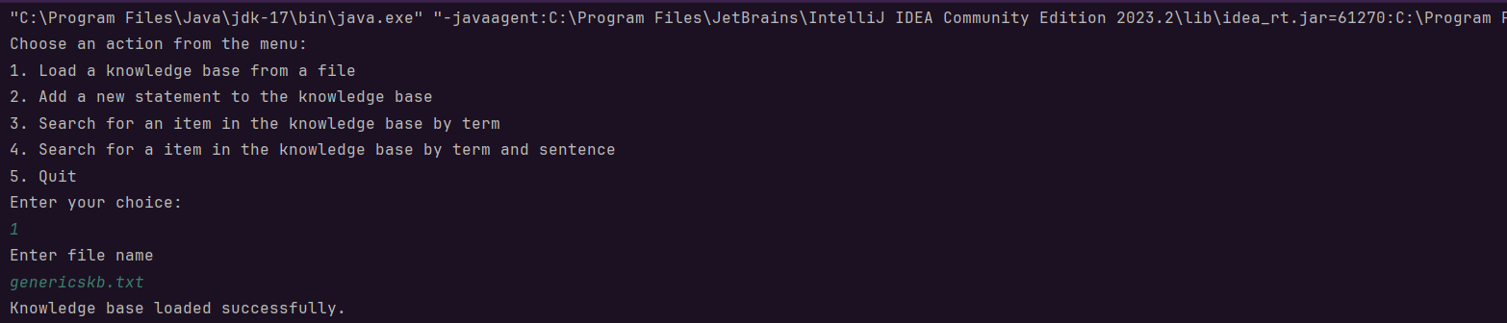Case 1:

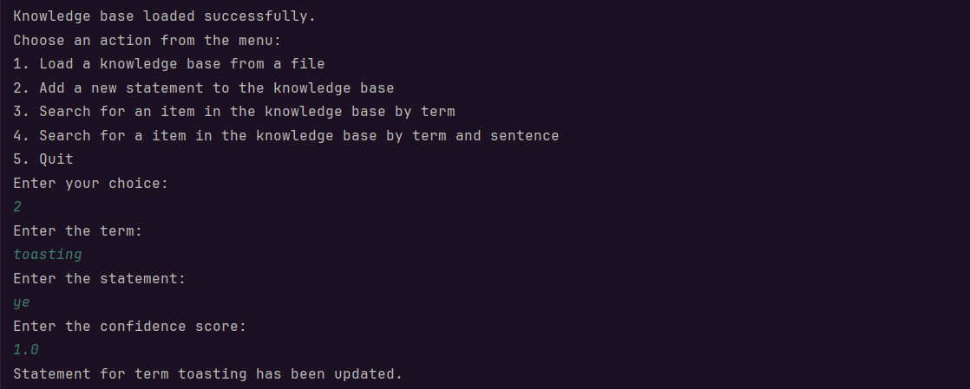Case 2:

Case 3:

:

Case 4:

Case 5:

**BST App:**

Case 1:

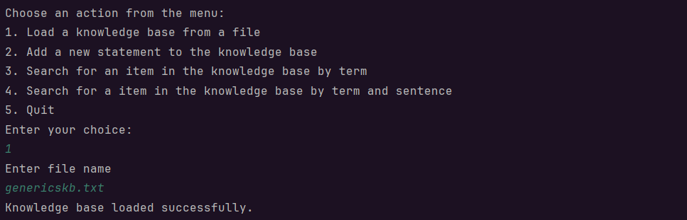

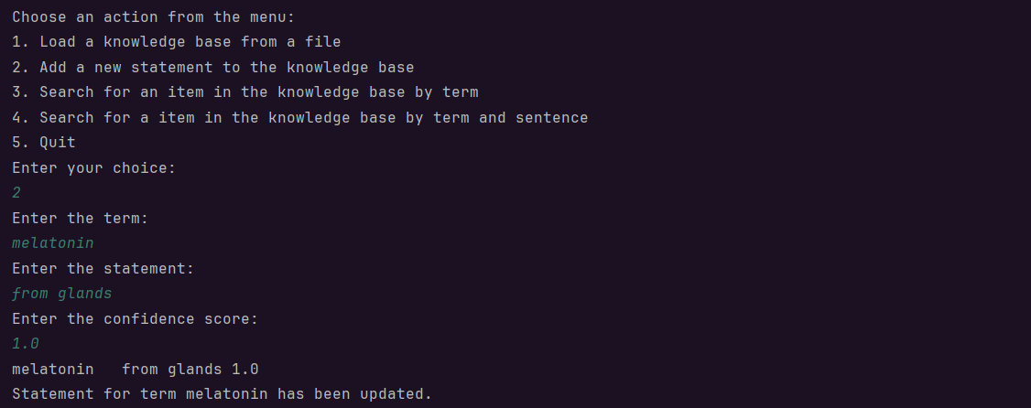Case 2:

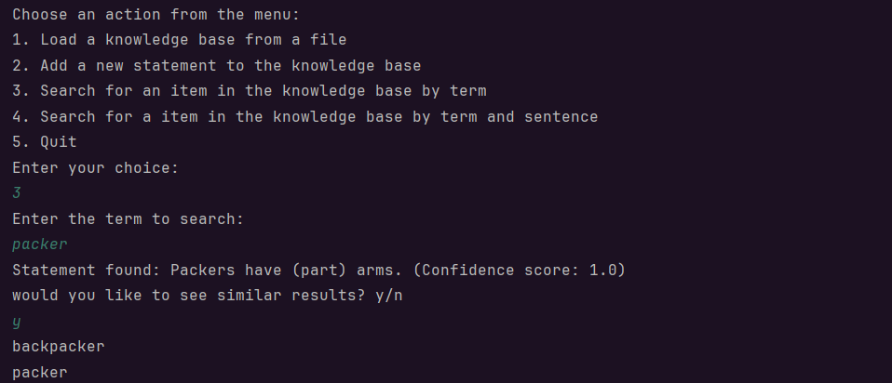Case 3:

Case 4:

Case 5: